H. Geometry - Hwk #37 Quiz Review Name: _________________________

Hour: ______

**Pythagorean Theorem**

**Write and solve an equation to find each missing length. If the answer is not a perfect square, leave it as the original square root or a decimal rounded to the tenths place.**

1. The bottom of a ladder is placed 4 feet from a wall. The ladder is 10 feet long. How far above the ground does the ladder touch the wall?

2. The bottom of a ladder is placed 5 feet from a wall. The ladder reaches 10 feet up the wall. How long is the ladder?

3. The area of a square is 121 square inches.

A) Find the length of a side.

B) Find the length of a diagonal.

4. George rides his bike 9 km south and then 12 km east. How far is he from his starting point?

5. Find the side of a rectangle that has a length of 15 feet and a diagonal of 25 feet.

6. To get from point A to point B you must avoid walking through a pond. To avoid the pond, you must walk 34 meters south and 41 meters east. To the nearest meter (whole number), how many meters would be saved if it were possible to walk through the pond?

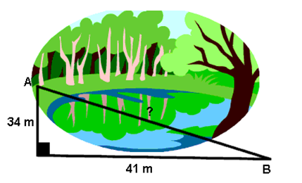

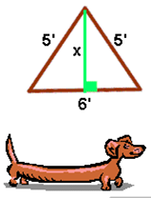7. Oscar’s dog house is shaped like a tent. The slanted sides are both 5 feet long and the bottom of the house is 6 feet across. What is the height of the dog house at its tallest point?

8. Dina made a small rectangular table for her workroom. The sides of the table are 36” and 18”. If the diagonal of the table measures 43”, is the table square? In construction, “square” means that there are right angles in all 4 corners—not that the shape is square.

9. A builder needs to add additional braces to a wall to support it. The wall is 16 ft wide and 12 ft high, as shown below. How much wire will be needed for both braces?

