H. Geometry Topic 14: Pythagorean Theorem Notes Date: ____________

**Objective 1: I can use the Pythagorean Theorem to find missing sides in right triangles.**

Recall that the Pythagorean Theorem is a way to find missing side lengths in _______________

_____________________.

|  |
| --- |
| **Pythagorean Theorem**  In a right triangle, the sum of the squares of the legs is equal to |

Example 1: Find the length of the missing side. Are you finding a leg or the hypotenuse?

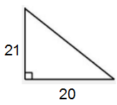A) B)

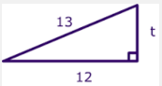

B) A right triangle has hypotenuse of length 25 and a leg of length 10. Find the length of the other leg.

Sometimes, you will be asked to simplify the square root into _____________________ form. This means NOT to get a decimal, but to remove the largest ______________________ from the radical sign and square root it. Let’s look at a couple of examples that use the simplest radical form.

Square Root Examples

   

Example 2: Solve for x. Leave your answer in simplest radical form.

A)

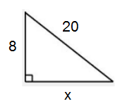

B) The hypotenuse of a right triangle has length 12. One leg has length 6. Find the length of the other leg. Leave your answer in simplest radical form.

Example 3: A) The Parks Department rents paddle boats at docks near each entrance to the park. To the nearest meter, how far is it to paddle from one dock to the other?

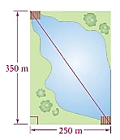

Ex 3 B.: When you want to know how far to paddle a boat, why is an approximate decimal answer more useful than an answer in simplest radical form?

Geometry Story Problems Using the Pythagorean Theorem

**Objective 2: I can set up and solve word problems using Pythagorean Theorem.**

1. The foot of a ladder is placed 6 feet from a wall. If the top of the ladder rests 8 feet up on the wall, how long is the ladder?

2. The bottom of a ladder must be placed 3 ft. from a wall. The ladder is 12 feet long. How far above the ground does the ladder touch the wall?

3. John leaves school to go home. He walks 6 blocks North and then 8 blocks west. How far is John from the school?

4. Scott wants to swim across a river that is 400 meters wide. He begins swimming perpendicular to the shore he started from but ends up 100 meters down river from where he started because of the current. How far did he actually swim from his starting point?

5. An isosceles triangle has congruent sides of 20 cm. The base is 10 cm. Find the height of the triangle.

6. What is the length of the diagonal of a 10 cm by 15 cm rectangle?

7. A baseball diamond is a square with sides of 90 feet. What is the shortest distance, to the nearest tenth of a foot, between first base and third base?

8. The area of a square is 81 square centimeters. First, find the length of a side. Then, find the length of the diagonal.

9. In a computer catalog, a computer monitor is listed as being 19 inches. This distance is the diagonal distance across the screen. If the screen measures 10 inches in height, what is the actual width of the screen to the nearest inch?