H. Geometry Topic 14: Pythagorean Theorem HW #35 Name: __________________________

Hour: _____

**Find each missing side.**

1. x = _______ 2. x = _______

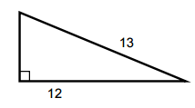 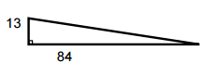

x

x

3. x = _______ 4. x = _______

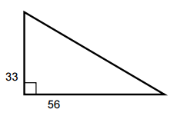 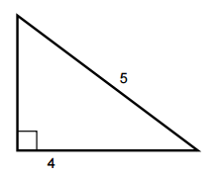

x

x

5. x = _______ 6. x = _______

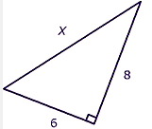

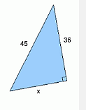

**Find each missing length. If necessary, leave your answer in simplest radical form.**

7. c = _________ 8. x = __________

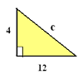 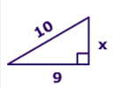

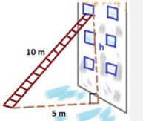9. A ladder is leaning against a building, as show to the right. How high up the building does the ladder rise? Leave your answer in simplest radical form.

*h* = __________

* x

10. A ladder is leaning against a building, as shown to the right.

How far is the base of the ladder from the building? Leave your

answer in simplest radical form.

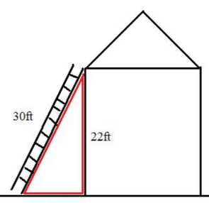

Distance = __________