9. Complete the proof.

|  |  |
| --- | --- |
| **Statements** | **Justifications** |
|  | Given |
|  |  |
|  |  |
|  |  |

Given:  , 

Prove: 

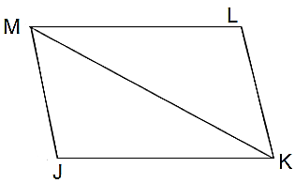

10. Complete the proof.

Given: 

|  |  |
| --- | --- |
| **Statements** | **Justifications** |
|  |  |
| K is the midpoint of |  |
|  | Definition of midpoint |
|  | Given |
|  |  |
|  |  |

K is the midpoint of  and .

Prove: 

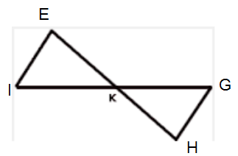

For #11-#16, are the two triangles congruent? If so, which postulate, SSS or SAS, is being used?

11. 12. 13.

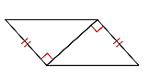 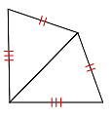 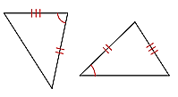

14. 15. 16.

