**H. Geometry - Bellwork #58 Date: _________**

**Part I: Give the name of the angle pair and their relationship (congruent or supplementary) in each diagram. Then find the value of the ? assuming that lines *u* and *v* are parallel.**

1. ________________________________ 2. ________________________________

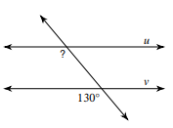 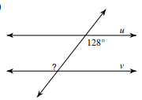

3. ________________________________ 4. ________________________________

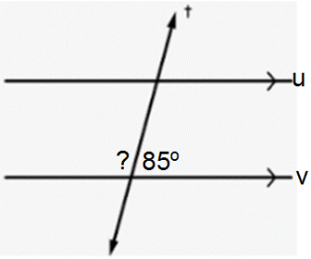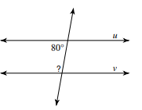

5. ________________________________ 6. ________________________________

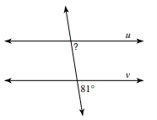 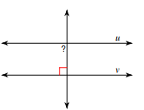

7. ________________________________ 8. ________________________________

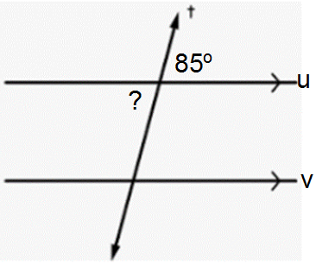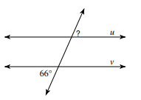

**turn to the back for more ☺**

**Part II: Find the value of x that makes lines *u* and *v* parallel.**

9. The angles in the diagram are ______________________________________ angles and they are

_____________________________ (choose congruent or supplementary).

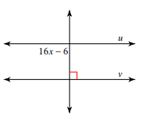

10. The angles in the diagram are ______________________________________ angles and they are

_____________________________ (choose congruent or supplementary).

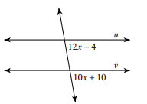

11. The angles in the diagram are ______________________________________ angles and they are

_____________________________ (choose congruent or supplementary).

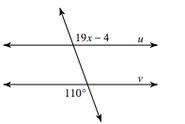

12. The angles in the diagram are ______________________________________ angles and they are

_____________________________ (choose congruent or supplementary).

