**H. Geometry - Bellwork #57 Date: __________**

1. Alternate Exterior Angles Proof: *Complete the proof by filling in the missing reasons.*

**Given:** line m || line k **Prove:** ∠2 ≅ ∠8

|  |  |
| --- | --- |
| Statements | Reasons |
| 1. line m || line k | 1. |
| 2. ∠2 ≅ ∠6 | 2. |
| 3. ∠6 ≅ ∠8 | 3. |
| 4. ∠2 ≅ ∠8 | 4. |

2. **Given:**  **Prove:** 

|  |  |
| --- | --- |
| **Statements** | **Justifications** |
|  |  |
|  |  |
|  |  |
|  |  |

3.

|  |  |
| --- | --- |
| **Statements** | **Justifications** |
| and |  |
|  |  |
|  |  |
|  | Transitive Property |
|  | Subtraction Property |
|  | Definition of Congruence |

4. In the diagram for #3, $m∠8=10x+10$ and $m∠12=12x-4$, what is $m∠16$?

**Turn to the back for two more proofs ☺**

5. **Given:** **Prove:** 

|  |  |
| --- | --- |
| **Statements** | **Justifications** |
|  |  |
|  |  |
|  |  |
|  |  |

6. **Given:**  **Prove:** 9 and 14 are supplementary

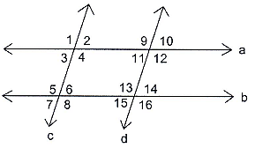

|  |  |
| --- | --- |
| **Statements** | **Justifications** |
|  |  |
|  |  |
|  | Alternate Interior Angles |
|  |  |
|  |  |