H. Geometry Topic 14: The Coordinate Plane

**Objective 1: Finding Distance on the Coordinate Plane**

Recall that a point is a _____ and a line is a series of ___________. In coordinate geometry, you describe a point by an ____________________________ (x, y) called the ___________________ of the point.

Review of the Coordinate Plane

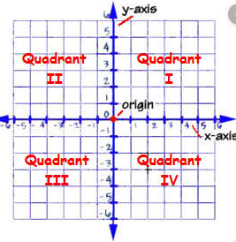

The distance between two points on the same horizontal or vertical line can be found quite easily by just _________________________________. However, to find the distance of two points that are not on the same horizontal or vertical line, you must use the distance formula.

|  |
| --- |
| **The Distance Formula**  The distance *d* between two points A( , ) and B( , ) is  *The distance formula is a derivation of the Pythagorean Theorem. |

Example 1: Find the distance between each pair of points to the nearest tenth.

A) T(5, 2) and R(-4, -1) B) A(1, -3) and B(-4, 4)

C) In either of the above examples, does it matter which point is first? Explain.

Example 2: Each morning Juanita takes the “Blue Line” subway from Oak Station to Jackson Station. As the map below shows, Oak Station is 1 mile west and 2 miles south of City Plaza. Jackson Station is 2 miles east and 4 miles north of City Plaza.

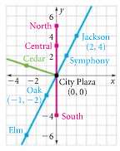

A) Find the distance Juanita travels between Oak Station and Jackson Station.

B) Find the distance between Elm Station and Symphony Station.

C) Maple Station is located 6 miles west and 2 miles north of City Plaza. Find the distance between Cedar Station and Maple Station.

**Objective 2: The Midpoint of a Segment**

To find the coordinate of the ______________ of a segment on a number line, find the ______ or _____________ of the coordinates of the endpoints. Recall that a midpoint is literally a *middle point.*

The midpoint of  is

We can extend this process to find the coordinates of the midpoint of a segment that is in the coordinate plane.

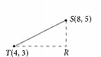Study the diagram of  with endpoints T(4, 3) and S(8, 5). Can you find the

midpoint of  using the idea from the previous page?

|  |
| --- |
| **The Midpoint Formula**  The coordinates of the midpoint *M* of with endpoints A( , ) and B( , ) are: |

Example 3: Find the midpoint of each segment given the endpoints.

A) Given that Q(3, 5) and S(7, -9), find the midpoint of 

B) Find the coordinates of the midpoint of  with endpoints X(2, -5) and Y(6, 13).

The next example shows how to find one of the endpoints if given an endpoint and the midpoint.

Example 4:

A) The midpoint of  is M(3, 4). One of the endpoints is A(-3, -2). Find the coordinates of B.

**Method 1: use the midpoint formula** **Method 2: use algebra**

B) The midpoint of  has coordinates (4, -6). X has coordinates (2, -3). Find the coordinates of Y. Use whichever method from above you prefer.