H. Geometry 6-3: Properties of Parallelograms Date: ________

**Objective: I can use the properties of parallel lines, diagonals, and triangles to investigate parallelograms.**

**Do “Critique and Explain” and Habits of Mind in your student companion, page 141.**

Answer these questions after you do the “Critique and Explain”.

1) Is all of the given information marked in the diagram? Is all of the information in the diagram written as a statement?

2) How many small triangles do the diagonals form?

3) How many triangles are formed by two adjacent small triangles?

Fill in the essential question for this section: What are the relationships of the ____________, the _____________, and the _________________________ of a parallelogram?

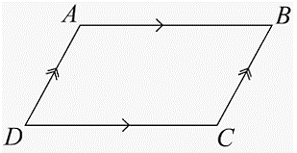

DEFINITION

A **parallelogram**

**Example 1:** How do the lengths of opposite sides of a parallelogram compare to each other?

Given: ABCD is a parallelogram.

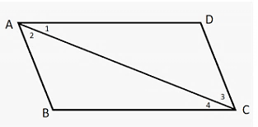

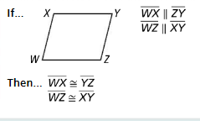**Do Try It 1, page 142 in your student companion.**

**Theorem 6-7:**

If a quadrilateral is a parallelogram, then

*Does Theorem 6-7 give any relationships between the lengths of adjacent sides?

**Example 2:** Quadrilateral PQRS is a parallelogram.

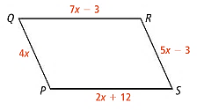

A) What is the value of x? B) What is the length of each side of PQRS?

**Do Try It 2 and Habits of Mind, page 142 in your student companion.**

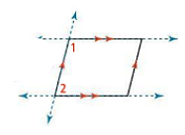**Example 3:** Explore the angle measures in a parallelogram.

A) How are consecutive angles in a parallelogram related?

B) How are opposite angles in a parallelogram related?

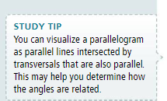

**Do Try It 3, page 143 in your student companion.**

**Theorem 6-8:**

If a quadrilateral is a parallelogram, then

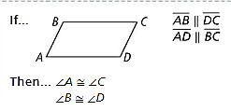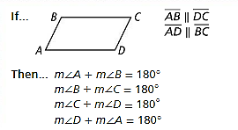

**Theorem 6-9:**

If a quadrilateral is a parallelogram, then

**Example 4:** The middle shape (green) in the fabric design is a parallelogram. The measure of $∠2$ is twice the measure of $∠1$. What are $m∠1, m∠2,$ and $m∠3$?

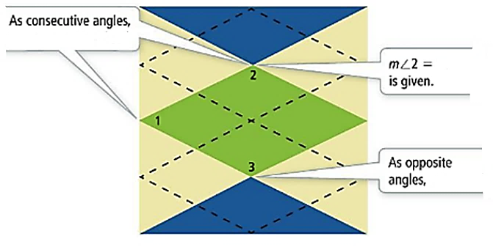

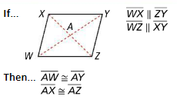**Do Try It 4 and Habits of Mind, page 144 in your student companion.**

**Theorem 6-10:**

If a quadrilateral is a parallelogram, then

A proof of theorem 6-10 follows.

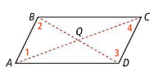**Example 5: $\overline{AC}$** and $\overline{BD}$ are the diagonals of parallelogram, ABCD.

**Given:** ABCD is a parallelogram.

**Prove**: $\overline{AQ}≅\overline{CQ}$, $\overline{BQ}≅\overline{DQ}$

|  |  |
| --- | --- |
| **Statements** | **Reasons** |
| 1. ABCD is a parallelogram | 1. |
| 2. $\overline{AB}≅\overline{DC}$ | 2. |
| 3. | 3. |
| 4. $∠1≅∠4$ and $∠2≅∠3$ | 4. |
| 5. $∆ABQ≅∆CDQ$ | 5. |
| 6. $\overline{AQ}≅\overline{CQ}$ and $\overline{BQ}≅\overline{DQ}$ | 6. |

**Do Try It 5, page 145 in your student companion.**

**Example 6:** Corey Stamps the pattern shown on the front of a poster she is making. How many times will she need to stamp the design to make a row 60cm wide along the dashed line?

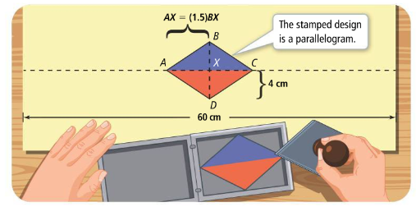

**Do Try It 6 and Habits of Mind page 145 in your student companion.**

**In your book:** Read Concept Summary and #1-12, page 268 (page 146 in student companion).

Tomorrow’s HW: page 269 #14, 16-21, 24, 26-28