**H. Geometry 6-2: Kites and Trapezoids Date: ______________**

**Objective:** I can use triangle congruence to understand kites and trapezoids.

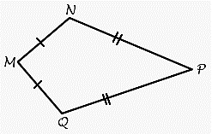

DEFINTIONS

A **kite**

An **isosceles trapezoid**

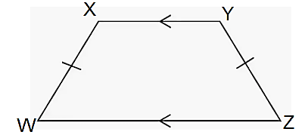

**Do “Critique and Explain” and Habits of Mind in your student companion, page 137.**

Fill in the essential question for this section: How are __________________ and ____________

measures related in ____________ and __________________?

**Example 1:** How are the diagonals of a kite related?

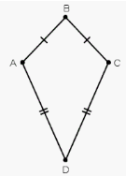

1) Draw in the diagonals. Name them. ________ and ________

2) What is true about the diagonals?

*

*

3) How could we verify that?

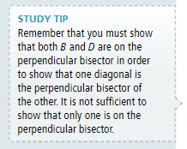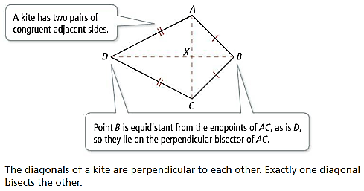

**Do Try It 1, page 138 in your student companion. Use kite ABCD from page 1 of your notes.**

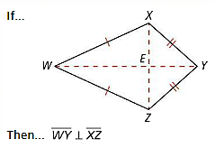

**Theorem 6-3:**

**Example 2:** Quadrilateral PQRS is a kite with diagonals $\overline{QS}$ and $\overline{PR}$.

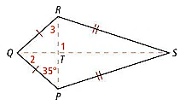

|  |  |  |
| --- | --- | --- |
| a) What is $m∠1$? Why? | b) What is $m∠2$? Why? | c) What is $m∠3$? Why? |

**Do Try It 2 and Habits of Mind, page 138 in your student companion.**

Can you determine $m∠WZX$ from the information given? Explain.

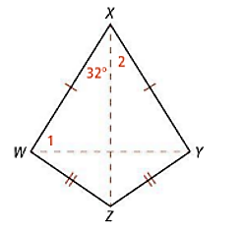

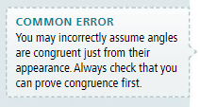

**Example 3:** Explore properties of an isosceles trapezoid.

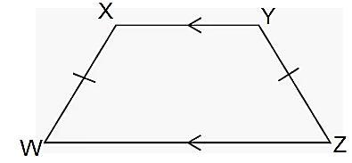

a) Because an isosceles trapezoid has 2 congruent sides, there must be congruent ______________.

b) Which angles do you think are congruent in the figure?

These angles are called the _________ angles.

c) What kind of angles are $∠X$ and $∠W$? Is there another pair of similar type angles?

d) Draw in the diagonals of the figure. Name them: _________ and _________.

What do you think is true about these diagonals? Can we verify that?

e) If $m∠W=70°$, find the measures of the remaining angles.

**Do Try It 3, page 139 in your student companion.**

**Theorem 6-5**:

**Theorem 6-4:**

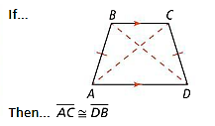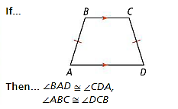

**Example 4**: All horizontal beams of transmission tower are parallel to the ground.

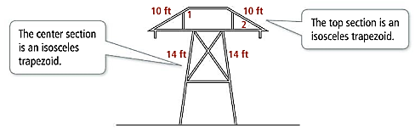

A) If $m∠1=138°$, what is $m∠2$?

B) One cross support in the center of the tower measures 4c + 3, and the other measures 6c – 5. What is the length of each cross support?

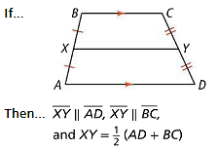**Do Try It 4 and Habits of Mind, page 139 in your student companion.**

**Note: A midsegment is**

**Theorem 6-6: Trapezoid Midsegment Theorem**

In a trapezoid, the midsegment is ____________ to the ___________, and is ___________ the _______ of the length of the bases.

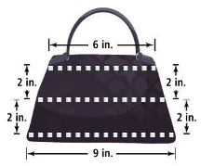**Example 5:** Paxton makes trapezoidal handbags for her friends. She

stiches decorative trim along the top, middle, and bottom of both

sides of the handbag. How much trim does she need for 3 handbags?

**Do Try It 5 and Habits of Mind, page 139 in your student companion.**

**In your Book**

Read Concept Summary and #1-11 page 259 (page 140 in your student companion).

Tomorrow’s assignment is page 260 #14, 16, 17, 19, 20, 22 (1760 yd = 1 mile), 24, 25, 26A