**H. Geometry 6-1: The Polygon Angle-Sum Theorems Date: ____________**

**Objective:** I can find the sums of the measures of the exterior angles and interior angles of polygons.

*Do “Explore and Reason” and Habits of Mind in your student companion, page 131.*

Fill in the essential question for this section: How does the number of ___________ in a convex

______________________ relate to the sum of the measures of its ______________ angles?

**Example 1:** How does the number of sides of a convex polygon, *n,* relate to the sum of the measures of its interior angles?

We know from earlier that the sum of the measures of the interior angles of a triangle is _____.

Draw a quadrilateral.

It can be decomposed (divided) into _____ triangles.

Draw a pentagon.

It can be decomposed (divided) into _____ triangles.

Draw a hexagon.

It can be decomposed (divided) into _____ triangles.

What kind of pattern do you see? Can you derive a formula for a polygon with “n” sides?

**Do Try It 1, page 132 in your student companion.**

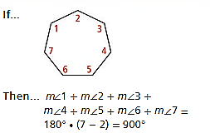This leads us to a theorem about the interior angles of a polygon.

**Theorem 6-1: Polygon Interior Angle-Sum Theorem**

The sum of the measures of the interior angles

**Additional Example:** The school zone traffic sign has 3 right angles and the other 2 angles are congruent. Find the measure of the other two interior angles.



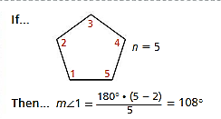

**Corollary to Theorem 6-1**

The measure of a single interior angle

**Example 2:** Jenna is building a corner cabinet to fit in a rectangular room. If she builds it with the angles shown, how can she determine whether the cabinet will fit?

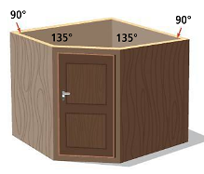

1) To fit in a corner, what must the 5th angle be (the one that is not labeled)?

2) What is the sum of the interior angles?

3) Does this sum make sense with the polygon interior angle-sum theorem?

**Do Try It 2 and Habits of Mind, page 132 in your student companion.**

**Example 3:** What is the sum of the EXTERIOR angle measures in a convex polygon?

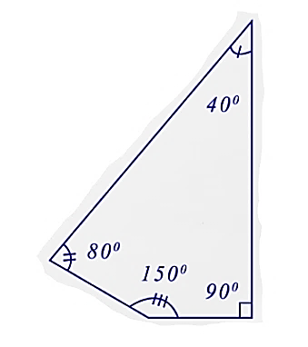

1) Find each exterior angle in the polygons below.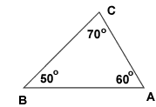

2) What do you notice about the sum of all of the exterior angles?

3) Do you think this is true for all polygons, regardless of the number of sides?

This leads us to a theorem about the exterior angles of polygons.

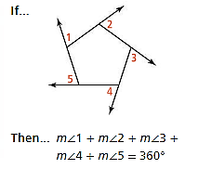

**Theorem 6-2: Polygon Exterior Angle-Sum Theorem**

The sum of the measures of the exterior angles

**Do Try It 3, page 133 in your student companion.**

**Example 4:**

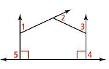

**Do Try It 4 and Habits of Mind, page 133 in your student companion.**

**Example 5: What are the measures of the interior angles of the pentagon shown?**

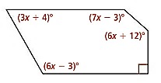

**Do Try It 5 and “Habits of Mind”, page 133 in your student companion.**

**Check for Understanding**

1) What is the sum of the angle measures of a linear pair?

2) What is the sum of an interior angle and an exterior angle at any vertex of a polygon?

3) Does the number of sides matter when finding the sum of the exterior angles?

**In your Book**

Read Concept Summary and #1-10 page 249 (page 134 in your student companion)

Tomorrow’s assignment is page 249 #13, 14, 16-25, 28, 29