**H. Geometry Topic 9: Hwk #30: ASA/AAS Name: ___________________________**

**Tell whether the ASA Postulate or the AAS Theorem can be applied to prove the triangles congruent. If the triangles cannot be proved congruent, write not possible.**

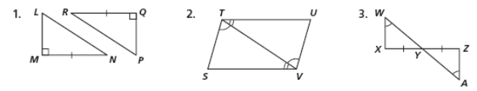

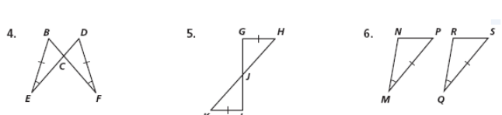

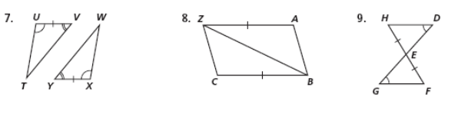

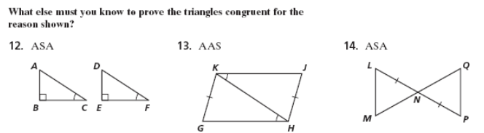

**Reminder: There are 3 Agile Mind Questions (write below):**