**H. Geometry Topic 9 HW #29: SSS/SAS Name: __________________________**

Decide whether you can use the SSS or SAS Postulate to prove the triangles congruent. If so, write the congruence statement and identify the postulate. If not, write *not possible*.

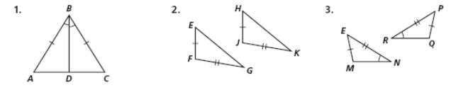

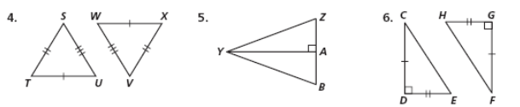

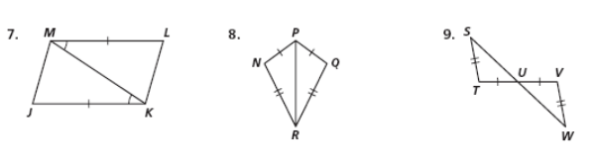

Draw a triangle. Label the vertices A, B, and C.

10. What angle is between and ?

11. What sides include ?

12. What angles include ?

13. What side is included between $∠A$ and $∠C?$