**H. Geometry Topic 9 - Hwk #28 Name: ___________________________**

**Use the given congruence statement to complete the missing information.**

1.   2.  

3.   4.  

5. . List three pairs ANGLES: SIDES:

of corresponding angles and three pairs

of corresponding sides.

**Write a congruence statement for each pair of congruent triangles below.**

6. 7.

________  ________ ________  ________

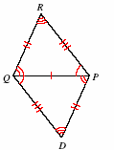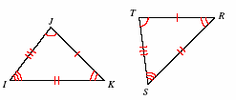

**Mark the corresponding angles and sides of each pair of triangles using the given congruence statement. Be sure to use the appropriate number of tick marks or arc marks.**

8.  9. 

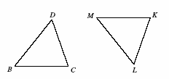 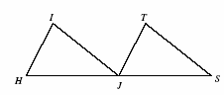

10. . **Fill in the missing information from polygon ABCD.**

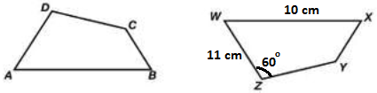



_______ = 10 cm