**H. Geometry Topic 10: The Hinge Theorem**

The Hinge Theorem is a theorem about how the sides and angles of a triangle are related.

|  |
| --- |
| **The Hinge Theorem:**  In a triangle, the smallest angle is opposite the smallest side,  the medium angle is opposite the medium side,  and the largest angle is opposite the largest side. |

Example 1: In  below, C is the smallest angle, A is the medium angle, and B is the largest angle.

Notice the side lengths.  is the shortest side and it is opposite C (the smallest angle).  is the medium side and it is opposite A (the medium angle). And  is the longest side and it is opposite B (the largest angle).

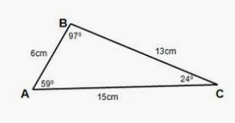

We use the Hinge Theorem to put side lengths and angles in order from smallest to largest, even if we don’t know their actual lengths or angle measures. It often helps to draw a triangle if one is not given to you.

Example 2: In , , , and . Put the sides of the triangle in order from shortest to longest.

Solution: Since  is the smallest angle, the side opposite it will be the shortest side.

Since  is the medium angle, the side opposite it will be the medium side.

Since  is the largest angle, the side opposite it will be the largest side.

Let’s draw and label a triangle to help us see the sides.

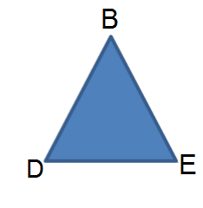 The smallest side is ______

The medium side is ______

The largest side is ______

