**H. Geometry Topic 10: Hinge Theorem Review**

The Hinge Theorem is a theorem about how the sides and angles of a triangle are related.

|  |
| --- |
| **The Hinge Theorem:**  In a triangle, the smallest angle is opposite the smallest side, the medium angle is opposite the medium side,  and the largest angle is opposite the largest side. |

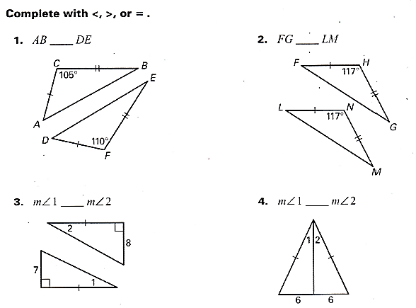

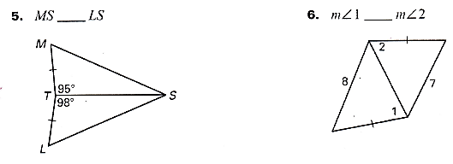

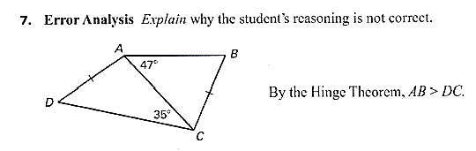

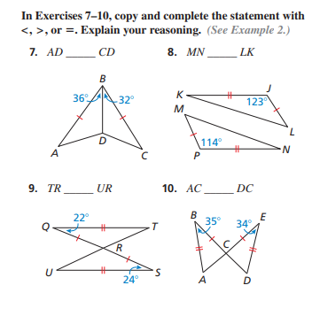**Practice Problems:**

1. What is the shortest side? _______

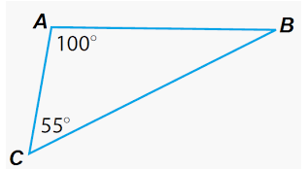

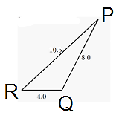2. Which angle is the largest? _________

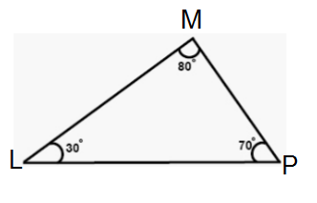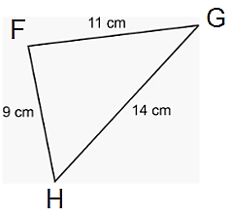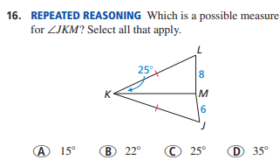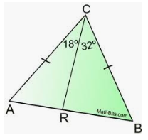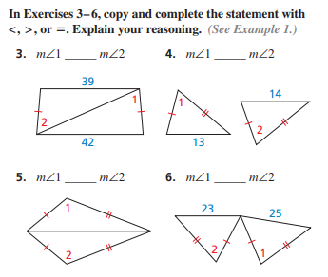

11. List the sides in order from shortest to longest.

12. List the angles in order from smallest to largest.

6.5. Which side is larger:  or ? Why?