**H. Geometry - Bellwork #51 Date: ______**



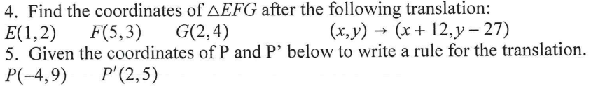

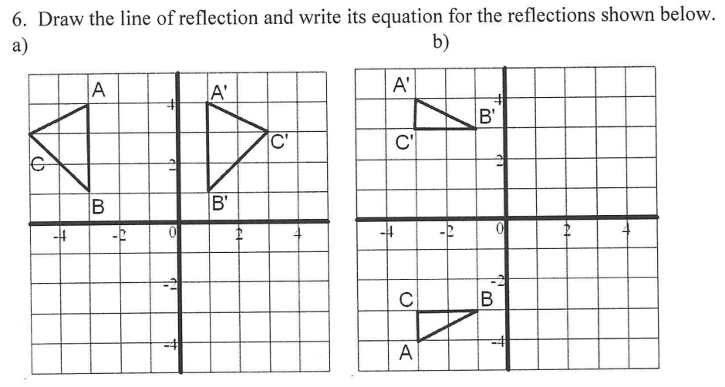

7. Find the coordinates of $∆TUV$ after the following translation:

8. Write the rule for the translation below: 9. Draw the image $∆JKL$ after reflecting over the line

10. For each of the parts below, find the coordinates of the image of point *X* (3, -2) after each reflection.

a) Reflect *X* over the x-axis. b) Reflect *X* over the y-axis. c) Reflect *X* over the line y = 2

