**H. Geometry – Bellwork #52 Date: __________**

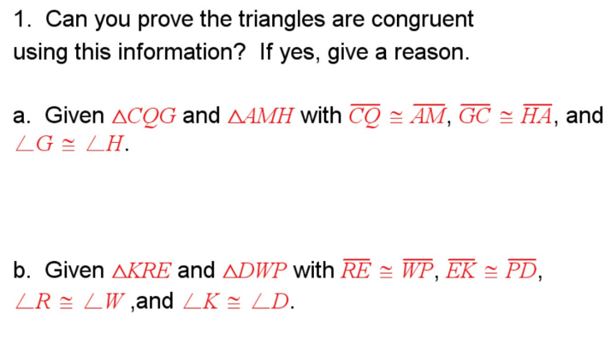

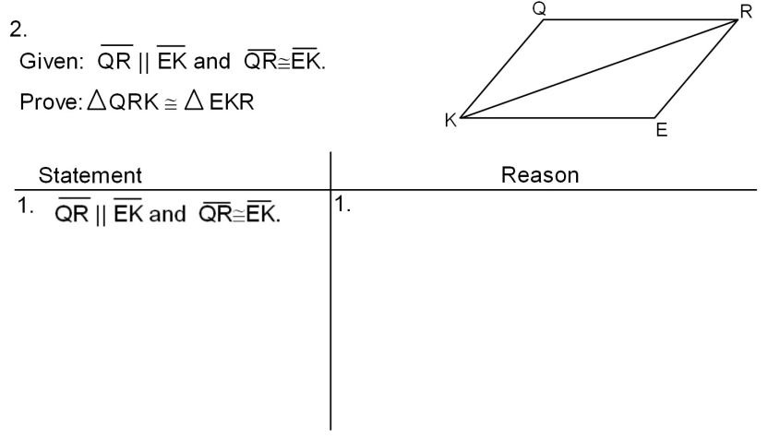

Name the two triangles that are congruent by the ASA postulate.

3. ___________  __________ 4. ___________  __________

Answer each question. Drawing a triangle may be helpful.

5. Which side is included between R and S in  ________

6. Which angles include  in  ______ and _______

Write a congruence statement for each pair of triangles. Name the postulate or theorem that justifies your statement. It may help to mark the “freebies”.

7. ____________________ 8. ____________________ 9. ____________________

Justification: _________ Justification: _________ Justification: _________

10. For the triangles given, , , and . Which of the following statements is true?

A)  by ASA

B)  by AAS

C)  by ASA

D)  by AAS

11.  and . What else must you know to prove ?

a) by AAS? B) by ASA?

12. Can you prove the triangles below congruent using ASA or AAS? Explain why or why not.

