I. Name the congruent triangles.

1. 2. 

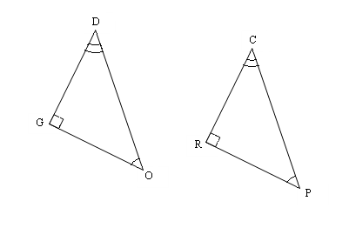

**C**

**O**

**G**

**R**

**A**

**E**

3.  4. 

A

I

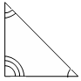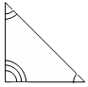

B

O

X

F

O

X

E

L

R

N

II. Name the congruent triangle and the congruent parts.

5. 

 

 

 

Use the congruency statement to fill in the corresponding congruent parts.

6.    

  

**Turn to the back for more ☺**

7. . Find x. 8.  Find y.

R

Q

N

M

P

x°

A

B

C

D

(3y)°

21°

35o

9. ΔABC ≅ ΔEFD ______________ 10. ΔABC ≅ ΔCDA ______________

C

A

D

B

C

A

B

D

F

E

11. ΔABC ≅ ΔEFD ______________ 12. ΔADC ≅ ΔBDC ______________

A

B

D

C

A

C

B

D

F

E

13. ΔMAD ≅ ΔMBC ______________ 14. ΔABE ≅ ΔCDE ______________

A

B

E

C

D

D

A

C

B

M