**H. Geometry – Bellwork #47 Date: __________**

1. Complete the proof.

|  |  |
| --- | --- |
| **Statements** | **Justifications** |
|  | Given |
|  |  |
|  |  |
|  |  |

Given:  , 

Prove: 

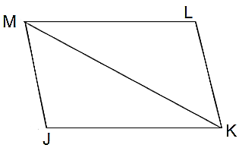

For #2-#7, are the two triangles congruent? If so, which postulate, SSS or SAS, is being used?

2. 3. 4.

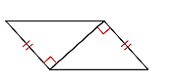 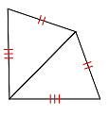 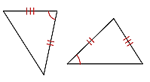

5. 6. 7.

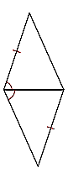 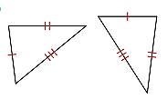 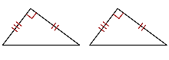

To prove triangles are congruent, you must find _____ **corresponding parts** that match up.

Triangle Congruence Theorems:

* **SSS Congruence:** When proving triangles congruent with SSS, you must find _____ ≅ sides.

* **SAS Congruence**: When proving triangles congruent with SAS, you must find _____ ≅ sides and _____ ≅ angle. You must have _____ **included** ___________.