**H. Geometry – Bellwork #45 Date: _____**

Find the missing angle in each triangle.

1. 2.

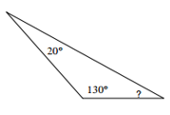 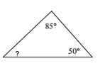

3. 4.

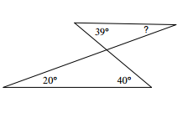 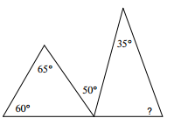

5. 6.

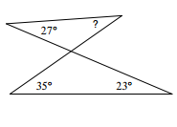 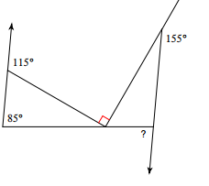

7. 8.

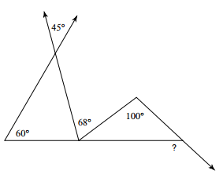 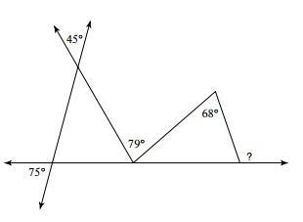

**Turn to the back for SAT Problems ☺**

9. 10.