**H. Geometry Name: _________________________**

**Hour: _____**

**Topic 7 Summary - Properties of a Triangle**

You have explored many relationships found in ____________________. You have either proven or prepared yourself to prove the following theorems related to triangles:

1. _________________________: The _____ of the lengths of any two sides of a triangle is __________ than the length of the third side.

2. _________________________: The _____ of the measure of the interior angles of a triangle is _____.

3. _________________________: The __________ of an exterior angle of a triangle is equal to the _____ of the measures of the remote interior angles.

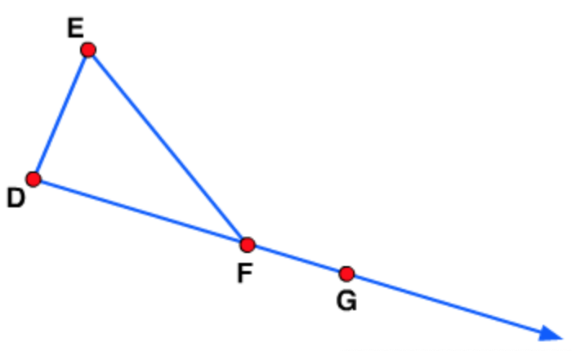

All these theorems will be important as you continue your study of geometry.

You also discovered relationships in ______________________________, including right triangles and isosceles triangles. You proved the ______________________________.

1. _________________________: The _____ angles of a triangle are complementary.

The ______________________________ relationships you conjectured about are also theorems. You will prove them in a later topic.

2. _________________________: The _____ angles of an isosceles triangle are __________.

* The __________ from the vertex to the __________ of the base of an isosceles triangle is ____________________ to the base and __________ the vertex angle.
* The __________ from the vertex to the __________ of the base of an isosceles triangle __________ the isosceles triangle into two __________ triangles.

