**H. Geometry Topic 7 HW #26 Triangle Sum Theorem Worksheet**

1. Why can a triangle never have two obtuse angles? Two right angles?

2. How could knowing the sum of the angles of a triangle help you find the sum of the angles of a quadrilateral? What about any polygon? (Hint: Draw pictures and create triangles.)

**Find the value of the variables in the triangles below.**

3. 4.

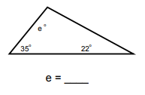 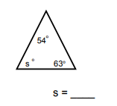

5. 6.

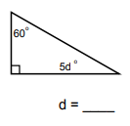 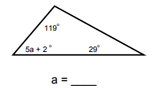

7. 8.

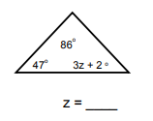 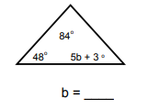

**REMINDER: THERE ARE FOUR AGILE MIND QUESTIONS TO COMPLETE (WRITE ON THE BACK).**