**H. Geometry Parallel Lines Classwork**

Do the following for each problem:

a) Identify the angles (linear pair, vertical, corresponding, alternate interior/exterior, same-side interior/exterior).

b) Identify the angles as congruent or supplementary.

c) Solve for x.

1. a. _______________________ 2. a. ________________________

b. _________________________ b. _________________________

c. x = _____ c. x = _____

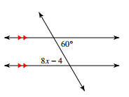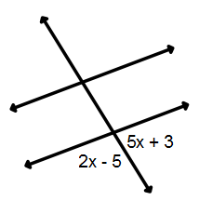

3. a. _______________________ 4. a. _______________________

b. _________________________ b. _________________________

c. x = _____ c. x = _____

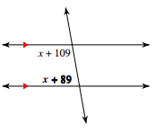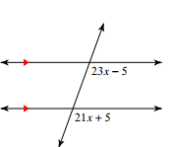

5. a. 6. a. __________________________

b. _________________________ b. _________________________

c. x = _____ c. x = _____

