**H. Geometry Topic 6 HW #21 Name: ________________________________**

**Part 1:**

**Directions: In each problem, (1) State the angle pair name of the given angles (2) Solve for the value of *x*.**

1. Find the value of x that makes lines *l* and *m* parallel. *x = ____________*

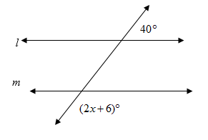

2. Find the value of x that makes lines *a* and *b* parallel. *x = ____________*

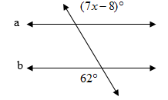

3. Find the value of x that makes the lines parallel. *x = ____________*

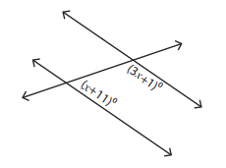

4. Find the value of x that makes the lines parallel. *x = ____________*

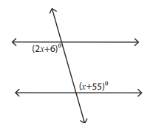

**Part 2: Agile Mind Online Questions (write on the back of this sheet)**