**H. Geometry Topic 7 HW #24: Classifying Triangles Name: ______________________________**

**Part 1: Classify each triangle by its sides and its angles on the lines below each triangle**

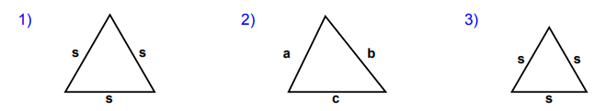

____________________ ____________________ ____________________

____________________ ____________________ ____________________

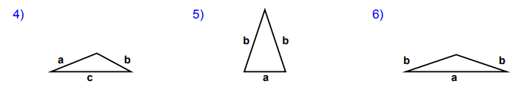

____________________ ____________________ ____________________

____________________ ____________________ ____________________

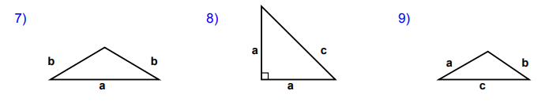

____________________ ____________________ ____________________

____________________ ____________________ ____________________

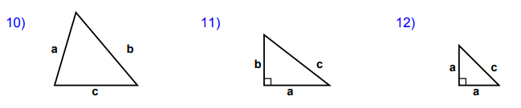

____________________ ____________________ ____________________

____________________ ____________________ ____________________

**Part 2: Agile Mind 6 Questions (write out on the back)**