Triangle Inequality Theorem
1. The sum of the lengths of any two sides of a triangle is ______________________ than the length of the third side.
2. Determine if the given side lengths form a triangle.
a) 4, 5, 10 b) 4, 5, 9 c) 4, 5, 7

The Triangle Inequality Theorem states that the sum of the lengths of any two sides of a triangle is greater than the length of the third side. Using this theorem, answer the following questions.
3. If two sides of a triangle are 1 and 3, the third side may be:
(a) 5 (b) 2 (c) 3 (d) 4

4. If the lengths of two sides of a triangle are 5 and 7, the length of the third side may not be:
(a) 12 (b) 7 (c) 3 (d) 5

5. Which set of numbers may represent the lengths of the sides of a triangle?
(a) {2,5,9} (b) {6,6,7} (c) {6,4,2} (d) {7,8,1}

6. If the lengths of two sides of a triangle are 4 and 10, which could be the length of the third side?
(a) 6 (b) 8 (c) 14 (d) 16

7. If the lengths of two sides of a triangle measure 7 and 12, the length of the third side could measure:
(a) 16 (b) 19 (c) 3 (d) 5

Turn to the back for more
8. If the lengths of two sides of a triangle are 10 and 14, the length of the third side may be:
(a) 22 (b) 2 (c) 24 (d) 4

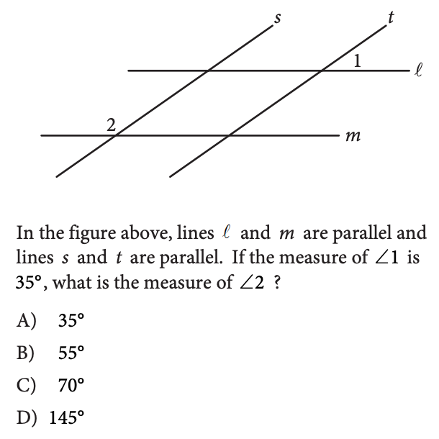
9.

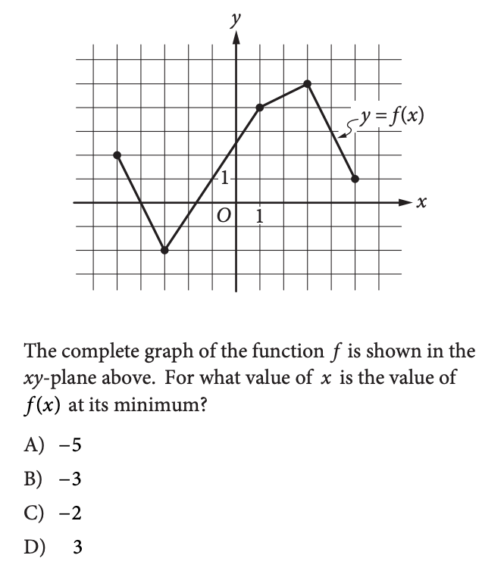
10.

