H. Geometry - Bellwork #41 Name: _______________________
Date: _____
Matching:
1. _____ Equilateral A. One angle measuring 90º
2. _____ Isosceles B. All angles are less than 90º
3. _____ Scalene C. All sides are congruent
4. _____ Right D. One angle measuring greater than 90º
5. _____ Acute E. No sides in the triangle are congruent
6. _____ Equiangular F. All angles are congruent
7. _____ Obtuse G. Two sides of the triangle are congruent

Solve for the missing variables:
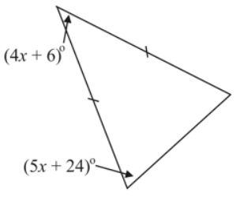
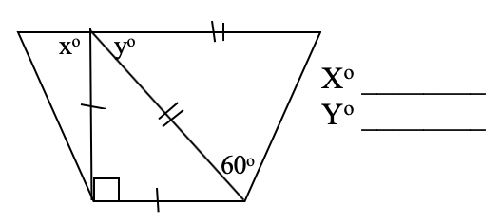
8. 9. X° __________

10. 11.
