**H. Geometry - Bellwork #38 Date: _________**

1. Classify each angle pair as *corresponding, alternate interior, alternate exterior,* *consecutive interior, or consecutive exterior.*

a) ∠1 and ∠9 ____________________

b) ∠8 and ∠13 ____________________

c) ∠6 and ∠16 ____________________

d) ∠4 and ∠10 ____________________

e) ∠8 and ∠16 ____________________

f) ∠10 and ∠13 ____________________

2. Find the missing variables.

75°

(5*x* – 10)°

(10*y* – 25)°

60°

(3*x* + 15)°

(–5*y* – 10)°

a. b. c.

3. For the following diagrams, state the type of angles that are given, state their relationship, and then find x.

a. b. c.

120°

3*x*°

(6*y* – 12)°

d. e. f.

100°

(*x* – 10)°

(2*y* + 24)°

**turn to the back for 2 practice SAT Questions ☺**

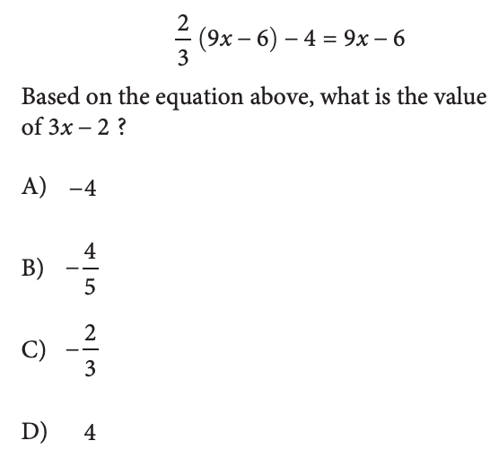4.

5.