**H. Geometry – Bellwork #36 Date: __________**

Complete the statements below:

1. If a transversal intersects two parallel lines, then corresponding angles are ____________________.

2. If a transversal intersects two parallel lines, then same-side interior angles are _________________.

3. If a transversal intersects two parallel lines, then alternate interior angles are __________________.

**Use the diagram below to answer questions 4 – 11. Justify your answers.**

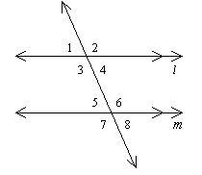

4. If , find . __________ 5. If , find . __________

6. If , find . __________ 7. If , find . __________

8. If , find . __________ 9. If , find . __________

10. If , find . __________ 11. If , find  __________

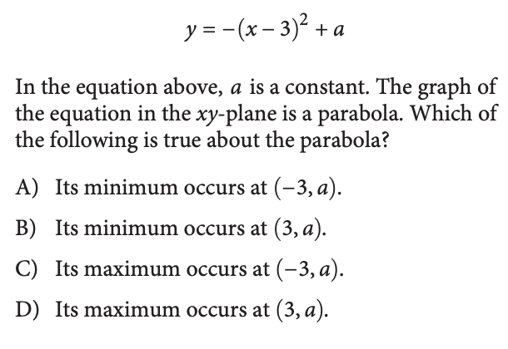

12. 13.