**H. Geometry – Bellwork #35 Date: ______**

1. Use this conditional:

If ten is divided by any number, then the result is a number less than ten.

a. State the hypothesis.

b. State the conclusion.

c. Is this conditional true? If not, give a counterexample.

2. Use this conditional: If a figure is a triangle, then it has three sides.

a. Is this conditional true? If not, give a counterexample.

b. Write the converse of this conditional.

c. Is the converse true? If not, give a counterexample.

3. Identify the hypothesis of the conditional: “If it is Saturday, then we do not go to school.

[A] If [B] then [C] it is Saturday [D] we do not go to school

4. Identify the conclusion of the conditional: “If it is Saturday, then we do not go to school.”

[A] If [B] then [C] it is Saturday [D] we do not go to school

5. Identify the correct converse of the conditional: “If it is Saturday, then we do not go to school.”

[A] If we do not go to school, then it is Saturday.

[B] If it is not Saturday, then we do go to school.

[C] If we go to school, then it is not Saturday.

[D] If it is Sunday, then we do not go to school

**turn to the back for Practice SAT ☺**

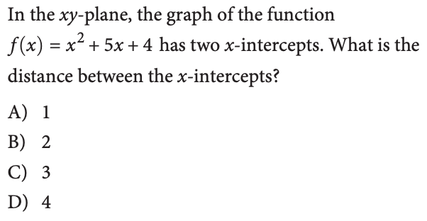6. 7.

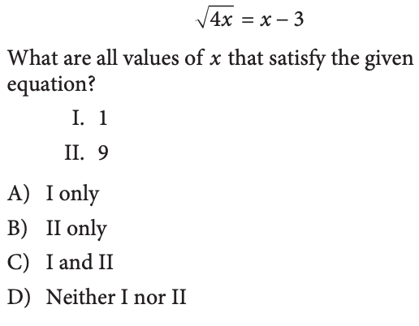

8. 9.