**H. Geometry - Bellwork #34**

**SAT Practice:**

1. The width of a rectangular dance floor is *w* feet. The length of the floor is 6 feet longer than its width. Which of the following expresses the perimeter, in feet, of the dance floor in terms of *w*?

A)

B)

C)

D)

2.

3.

What is the solution set of the equation above?

A) {-1}

B) {5}

C) {-1, 5}

D) {0, -1, 5}

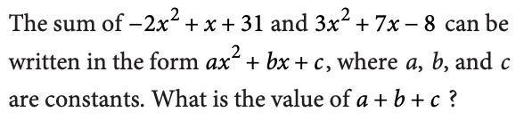

4.

5.

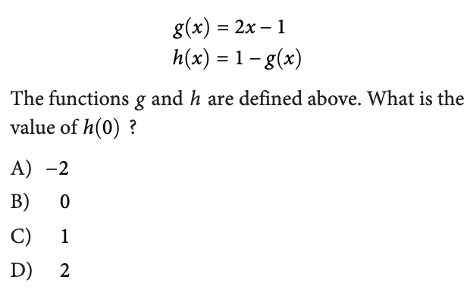

6.

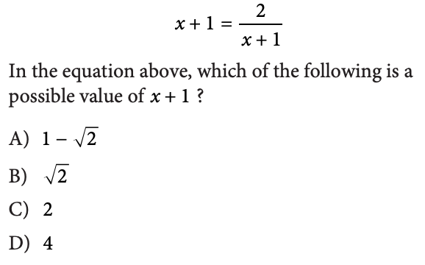

7.

8.

