Geometry Topic 3 Review Name: ___________________________  
 Hour: _____

**Objective: I can find images after a translation and write translation rules.**

1. Translate triangle ABC using the rule (x, y) 🡪 (x + 6, y – 2). Be sure to label the image. Use this to also answer questions 2 and 3.

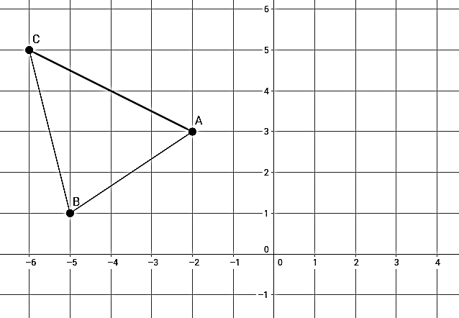

2. What directions are you moving?

______________ and _____________

3 What are the coordinates of A’B’C’?

A’ ( )

B’ ( )

C’ ( )

4. Write a rule that shows how ABC 🡪 A’B’C’.

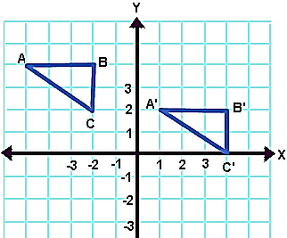Rule: _________________________________

**Objective: I can find images after a reflection.**

5. Draw the image reflected across the x-axis. Write the coordinates of the image below.

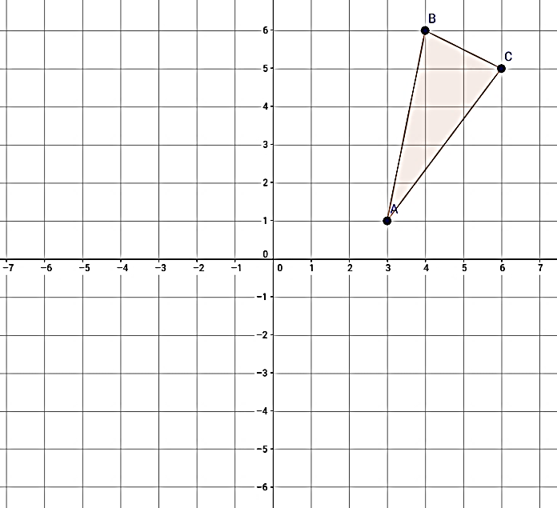

**y**

A’ __________

B’ __________

C’ __________

**x**

6. Draw the image reflected across the y-axis. Write the coordinates of the image below.

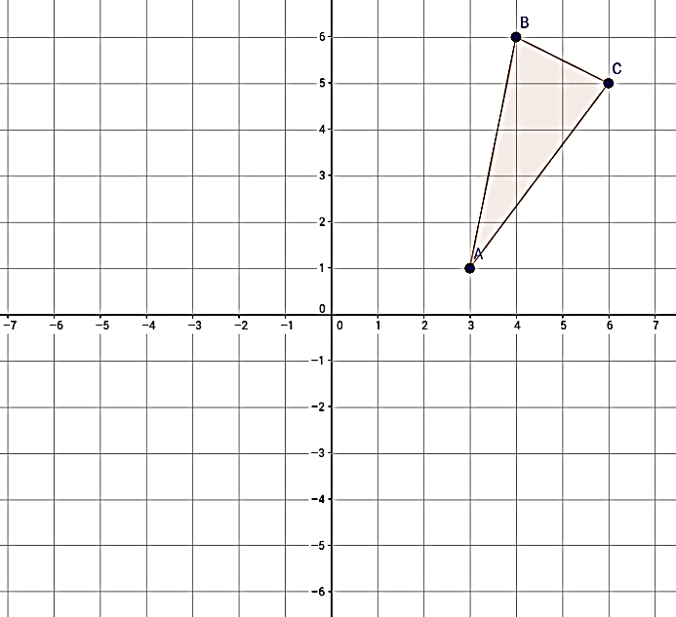

**y**

A’ __________

B’ __________

C’ __________

**x**

7. If A(-3, 4) 🡪A’ (-3, -4) then A was reflected across the _____ axis.

8. If B (2, 1) 🡪 B’(-2, 1), then B was reflected across the ___ axis.

9. If T has coordinates (-3, 4), what would the coordinates of T’ be after a reflection over

the line y = x?

**Objective : I can rotate images and find degrees and directions of rotations.**

**Use 90 $°$ CW, 90 $°$ CCW, or 180 $°$ for your amounts and directions of rotation.**

10. Rotate the given points in the direction indicated.

A (-4, 2): Rotate 90 $°$ CW: A’ __________

B (3, 5): Rotate 90 $°$ CCW: B’ ___________

C (2, -1): Rotate 180 $°$: C’ __________

Describe how each set of points or figure has been rotated.

11. P’Q’R’S’ has been rotated ____________________ from PQRS.

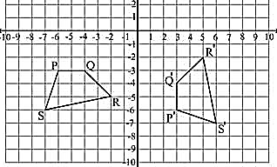

12. M (-4, 3) 🡪 M’ (4, -3)

M’ has been rotated _________________ from M.

13. Q’L’M’N’ has been rotated ______________ from QLMN.

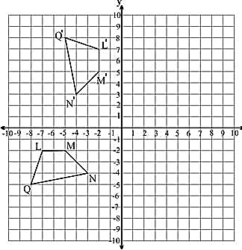

**Objective: I can find images after a dilation.**

14. What is the dilation factor from ABC 🡪 A’B’C’? Dilation Factor __________

**y**

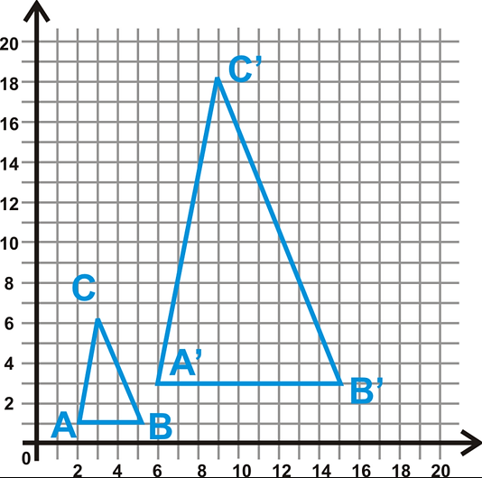

**x**

15. Describe if the dilation factor is a reduction, an enlargement, or an isometry.

a) scale factor = 2 _________________________

b) scale factor = -1 _________________________

c) scale factor = 0.8 _________________________

**y**

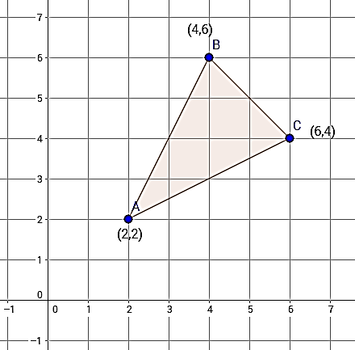16. Dilate the figure at the right

using a scale factor of .

Identify the coordinates of the image.

A’ __________

B’ __________

C’ __________

**x**

**Objective: I can describe multiple transformations.**

8. Which 2 transformations that took place so that ABCD 🡪 A’’B’’C’’D’’.

If rotation, give degrees and direction.

If translation, give directions and number of units, or write a rule.

If reflection, tell over which axis.

If dilation, tell what the scale factor is.

Transformation #1: __________________________________

Transformation #2: __________________________________

**y**

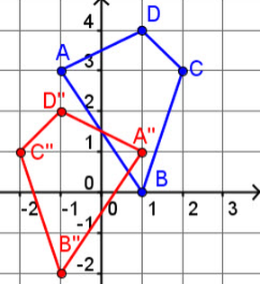

**x**