**H. Geometry Name: _____________________________**

**Topic 4: Angle and Segment Addition HW Hour: ________**

1. TU = _______ 2. HI = ________

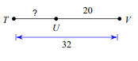

3. If DT = 60, find the value of x. 4. Find the value of x. Then find NM and LK.

Then find DS and DT. x = _______

x = ______ NM = ________

DS = ______ LK = _______

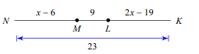DT = ______

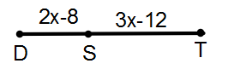

5. What is if 6. If , find



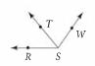and ?



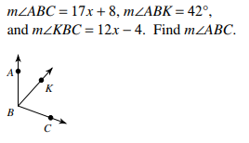7. Solve for *x* if 8.



and .



