**Name each property being used.**

1.  5. Which of the following is an example of the Reflexive Property of Equality?

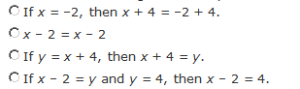

2. If x = 2 and x = y, then y = 2.

3. If x = 3 and 2x + 7 = 4y, then 2(3) + 7 = 4y.

4. If , then 

6. Fill in the missing information in the proof below.



**Statements Justifications**

1. AB + BC = AC 1. ____________________________

2. _____________________ 2. Substitution

3. 5x + 1 = 36 3. ____________________________

4. _____________________ 4. Subtraction Property of Equality

5. x = ______ 5. ____________________________

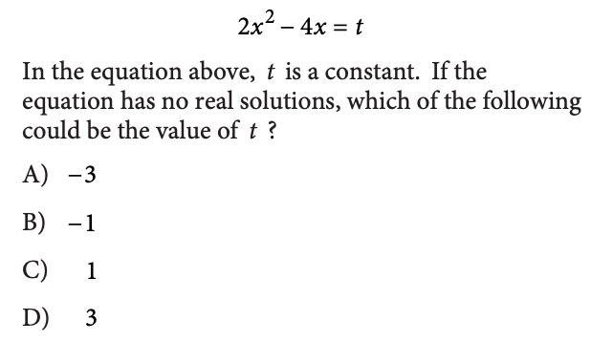

7. 8.

**turn to the back for #9 ☺**

9.