H. Geometry - Bellwork #29

Practice SAT Questions

1. $y=x^{2}$
$2y+6=2(x+3)$

If $(x,y)$ is a solution to the system of equations above and $x>0$, what is the value of $xy$?

2. If $a^{2}+b^{2}=z$ and $ab=y$, which of the following is equivalent to $4z+8y$?

A) ${\left(a+2b\right)}^{2}$

B) ${\left(2a+2b\right)}^{2}$

C) ${\left(4a+4b\right)}^{2}$

D) ${\left(4a+8b\right)}^{2}$

3. $\frac{2x+6}{{\left(x+2\right)}^{2}}-\frac{2}{x+2}$

The expression above is equivalent to $\frac{a}{{\left(x+2\right)}^{2}}$, where $a$ is a positive constant and $x≠-2$. What is the value of $a$?

Date: _______

4. Intersecting lines $r, s,$ and $t$ are shown below.

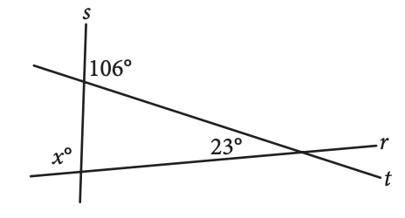

What is the value of $x$?

5. $-2x+3y=6$

In the $xy$-plane, the graph of which of the following equations is perpendicular to the graph of the equation above?

A) $3x+2y=6$

B) $3x+4y=6$

C) $2x+4y=6$

D) $2x+6y=3$

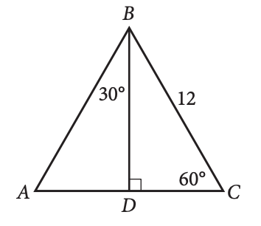

6.

In $∆ABC$ above, what is the length of segment AD?

A) 4

B) 6

C) $6\sqrt{2}$

D) $6\sqrt{3}$

