H. Geometry - Bellwork #23 Tuesday, October 8th, 2019
Without graphing, determine the reflection points of each pre-image.
1) Reflection across the x-axis 2) Reflection across the x-axis
F (-5, -3), R (-3, 0), N (0, -1) B (-2, 1), S (-2, 2), R (3, 3), J (2, -2)

3) Reflection across the y-axis 4) Reflection across the y-axis
M (0, -1), S (3, 2), Q (5, -3) V (3, -5), E (1, -2), F (3, 0), M (5, -2)
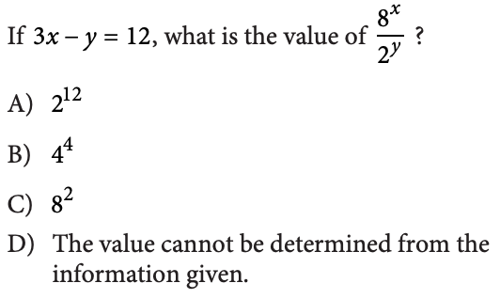
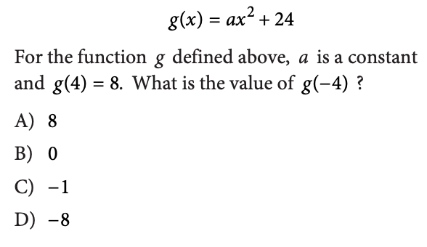
5) 7)

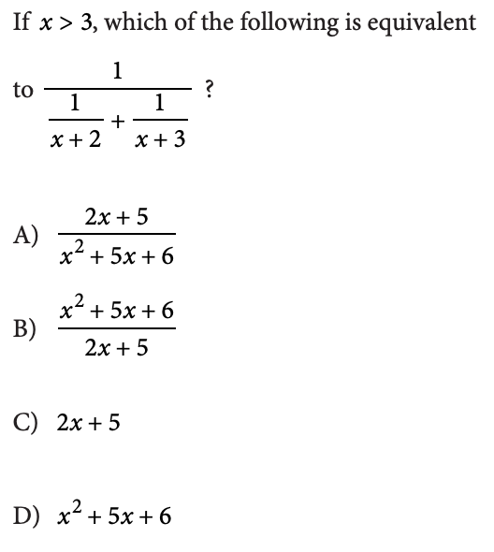
6)

