**H. Geometry - Bellwork #8 Date: __________**

**Use the diagram below for questions 1 – 4.**

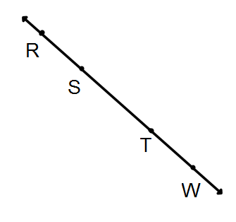

1. Name all labeled segments.

2. Name all labeled rays.

3. Name a pair of opposite rays with T as the endpoint.

4. Name another pair of opposite rays that do not start at T.

5. Draw a line segment with endpoints D and L.

6. Draw opposite rays  and .

7. True or False: Opposite rays always form a line. _________

**Fill in the blank with *always, sometimes,* or *never.***

8. and  are ________________ the same line.

9.  and  are ________________ the same ray.

10.  and  are ______________ the same segment.

11.  and  are _______________ the same part of a line.