**H. Geometry - Bellwork #6 Date: __________**

1. Points that are on the same line are also called _______________________.

2. A _______________________ is a series of points that extends in opposite directions without end.

3. Two lines are _______________________ if they are noncoplanar and do not intersect.

4. A _______________________ is the part of a line consisting of one endpoint and all points in one direction.

**Use the figure at the right to answer questions 5-7.**

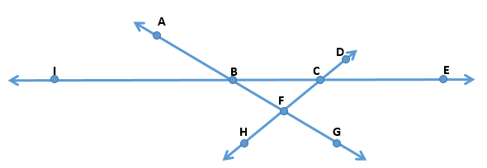5. Name line *x* in 3 other ways.

i)

ii)

iii)

6. Line *y* and line *z* intersect at point _____.

7. Are the following points collinear? (Yes or No) If yes, name the line on which they lie.

a.) A, B, G b.) A, B, C

**Use the figure at the right to answer questions 8-10. Be sure to use proper symbols!**

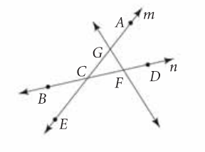

8. Name line *m* two other ways.

9. Name two line segments.

10. Name a pair of opposite rays.

**Use the figure at the right to answer questions 11-14.**

11. Plane JKPN and Plane GHJK intersect at ________.

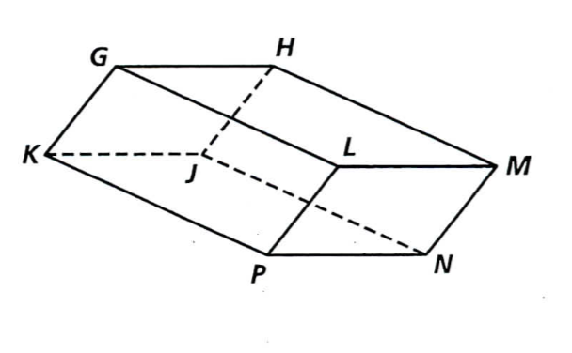

12. Plane HML and Plane PNL intersect at ________.

13. L, P, K, and ______ are coplanar.

14. Plane KJH and Plane LMH intersect at _____.