**H. Geometry - Bellwork #18 9-27-19**

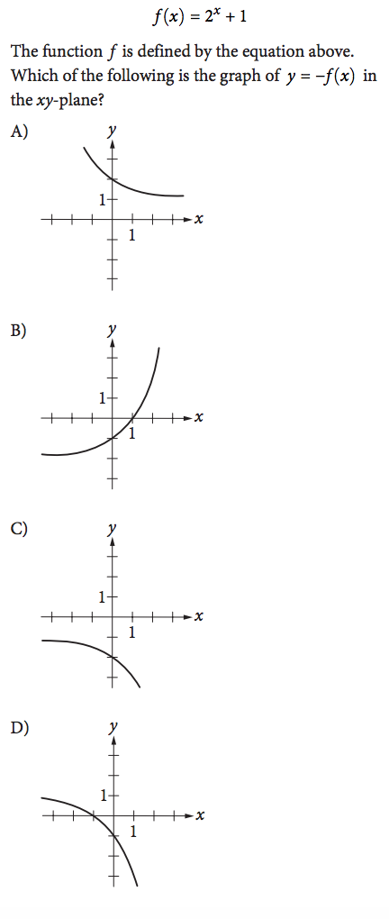

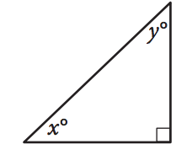1. 2.

In the triangle above, the sine of angle *x* is 0.6.

What is the cosine of angle *y*?

3) Rotate ALT if A(-5,-1), L(-3,-2), T(-3,2) 4) Reflect TAB if T(2,3), A(1,1),   
 clockwise around the origin, then reflect and B(4,-3) over the x-axis, then translate  
the image over the y-axis. the image by moving it left 5 and down 4.