**H. Geometry - Bellwork #17 Date: __________**

1. Find the coordinates of $∆TUV$ after the following translation:

2. Write the rule for the translation below: 3. Draw the image $∆JKL$ after reflecting over the line

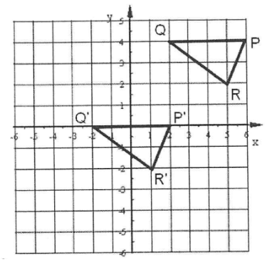

4. For each of the parts below, find the coordinates of the image of point *X* (3, -2) after each reflection.

a) Reflect *X* over the x-axis. b) Reflect *X* over the y-axis. c) Reflect *X* over the line y = 2

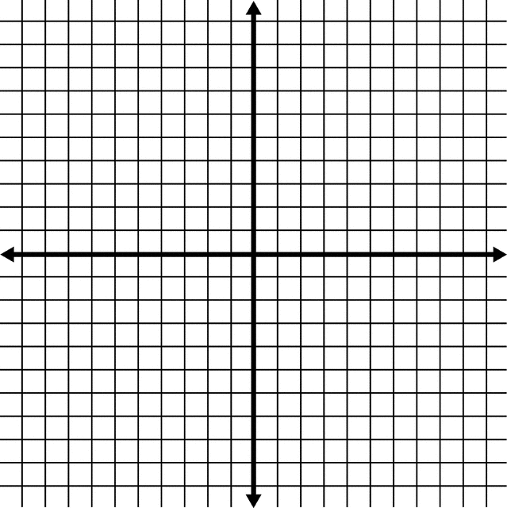

5. Draw the image $∆XYZ$ after each rotation.

*X* (3, 0) *Y*(3, 4) *Z*(5, 2)

a) 180 $°$ CW b) 90 $°$ CCW c) 90 $°$ CW

  