H. Geometry - Bellwork #13 Date: __________

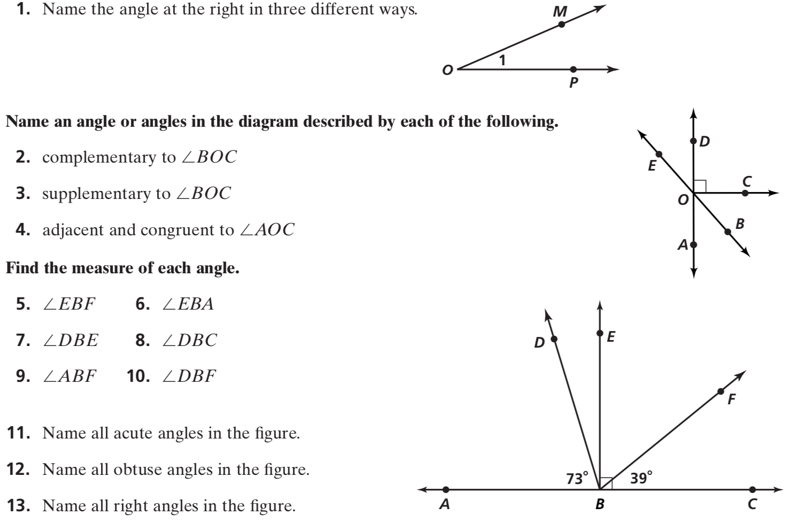

H. Geometry - Bellwork #13 Date: __________

