**H. Geometry - Bellwork #12 Date: __________**

1. Draw and label point W. 2. Draw and label line GH.

3. Draw and label line segment NP. 4. Draw and label ray KL.

5. Draw and label ray LK. 6. Draw and label opposite rays NC and NY.

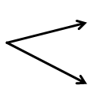7. Label the angle below as . What two rays form this angle?

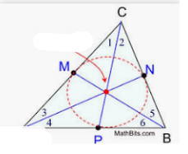**Use the diagram below to answe questions 8 – 11.**

8. What is the name of the point that the arrow is pointing at?

9. What important lines of the triangle meet at this point?

10. What is true about  and ?

11. Find  and  if  and 

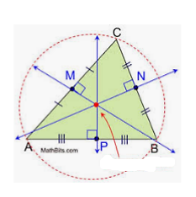

**Use the diagram below to answer questions 12 – 15.**

12. What is the name of the point that the arrow is pointing at?

13. What important lines of the triangle meet at this point?

14. What is true about and ?

15. Find CN and NB if CN =  and NB =

16. How is inductive reasoning different from a conjecture? Give examples if needed.