H. Geometry Unit 1 Review

Vocabulary Words
Points that lie on the same line are _____________________.

Points and lines that lie on the same plane are _____________________.

Two parts of a line are a _______________ and a ____________.

Lines that are coplanar and do not intersect are _____________ lines.

Lines in space that are not parallel and do not intersect are ________ lines.

Planes that do not intersect are _________________ planes.

Use the diagram below to answer questions 1 – 5. Use the diagram below to answer questions 6 – 9.
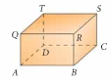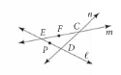
1. Name three lines that intersect at R.

2. Points D, T, S and ____ are coplanar. 6. Name line m in two other ways.

3. Plane QTSR is parallel to plane __________. 7. C is the intersection of which two lines?

4. Name a line that is parallel to$\vec{\text{BC}}$. 8. Name three collinear points.

5. Name a line that is skew to$\vec{\text{BC}}$. 9. Are P, E, and C collinear?

Use the diagram below to answer questions 10-12.
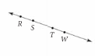
10. Name 3 line segments. 11. Name 3 rays. 12. Name a pair of opposite rays.

Vocabulary Words
Segments with the same length are _______________ segments.

The _____________ of a segment divides the segment into two congruent segments.

Two rays with the same endpoint form an __________.

Angles with the same measure are _____________ angles.

Acute angles measure ___________________________.
Obtuse angles measure _______________________________________.

Right angles measure _____________________________.

Straight angles measure ___________________________.

1. JK = 48. Find x, JH and HK. 2. Find m, AB, BC, and AC.
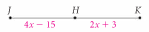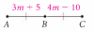

Use the diagram below for questions 3 and 4.

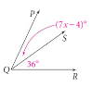
3. The $m∠\text{PQR}=\text{82}°$. Find $m∠\text{PQS}\text{.}$ 4. Find $m∠\text{PQS}$if $m∠\text{PQR}=4x+\text{47}$.

Use the diagram for questions 5 – 10.
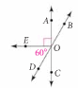
5. Name a right angle.

6. Name a pair of vertical angles.

7. Name a pair of complementary angles.

8. Name a pair of supplementary angles.

9. Name an angle adjacent to$∠\text{DOE}$.

10. Given $m∠\text{EOD}=\text{60}°$, find all other individual angles.

