**H. Geometry - Bellwork #47**

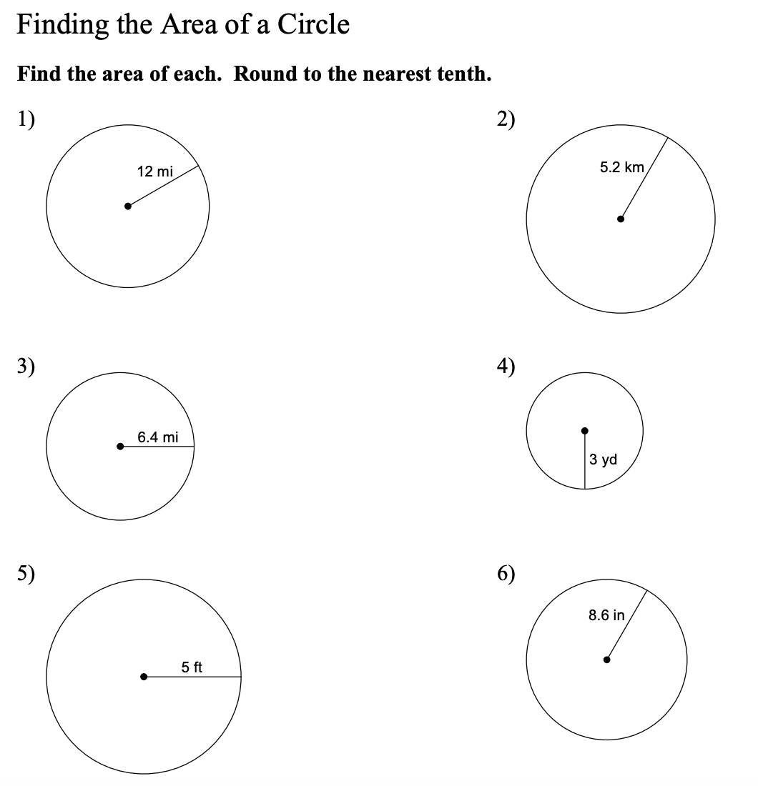

**7.**

