Geometry 12-3: Inscribed Angles

Objective 1: I can find the measure of an inscribed angle.

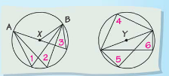
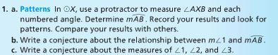
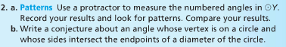

Below, the vertex of _____ is on ________, and the sides of ______ are _______ of the circle.

______ is an _________________. _____ is the ____________________ of _____.

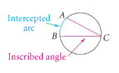

Theorem 12-9 describes the relationship between an inscribed angle and its intercepted arc.
Theorem 12-9: Inscribed Angle Theorem
The measure of an inscribed angle is _________________________ of its intercepted arc.
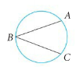

There are three different ways that an angle can be inscribed inside of a circle.

I. II. III.
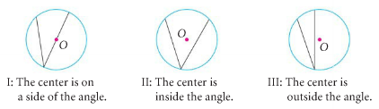

Regardless of where the center of the circle is located, you will still use Theorem 12-9 to find the measure of inscribed angles.

Example 1: Use Theorem 12-9 to find the measure of inscribed angles.
A) Find the values of a and b.

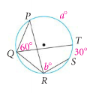

B) Use the diagram above and find if .

C) Find the values of x and y.

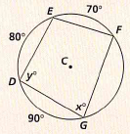

These corollaries below will help you find the measures of angles in circles.

Corollaries to the Inscribed Angle Theorem:
(1) Two inscribed angles that intercept the same arc are ________________.

(2) An angle inscribed in a semicircle is a ___________________.

(3) The opposite angles of a quadrilateral inscribed in a circle are ____________________.

Example 2: Use the above corollaries to find the measure of the numbered angles.
A) B)
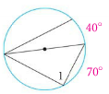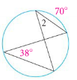

C) D) Find the values of a and b.
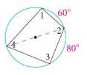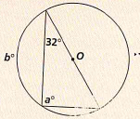

Objective 2: I can find angles formed by a tangent line and a chord.
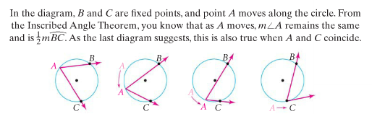

Theorem 12-10
The measure of an angle formed by a _________ line and a _______ is _______ the measure of the __________________.
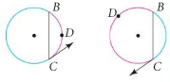

Example 3:
A) In the diagram below, is tangent to the circle at J. Find the values of x and y.
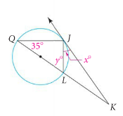

B) How could we find ?

Example 4: and are diameters of . is tangent to at point R. Find and

