Geometry 12-2: Chords and Arcs

Objective 1: I can use congruent chords, arcs, and central angles in circles.

A segment whose endpoints are on a circle is called a ___________.

1. Label the circle below left as O.
2. Label its chord in the circle as .
3. By drawing chord , we also get its related ______, . An _____ is a part of the _________________ of a circle.

A _____________________ of a circle is an angle formed by any two ____________ in a circle. The ______________ is the center of the circle.
4. Label the circle at the right as P.
5. Draw its central angle

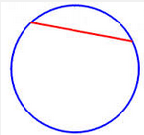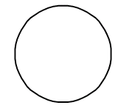

The following theorem is about ____________ central angles, chords, and arcs. It says, for example, that if two central angles in a circle are congruent, then so are the two chords and two arcs that the angles intercept.

Theorem 12-4:
Within a circle or congruent circles

(1)

(2)

(3)

We generally use Theorem 12-4 to show that parts in a circle are congruent.
Example 1: In the diagram below,.
A) Given that , what can you conclude?

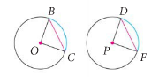

B) If we are told in the diagram above that instead, then what can you conclude?

QC 1: In the circle below, radius bisects . What can you conclude?

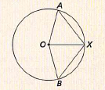

Theorem 12-5
Within a circle or in congruent circles

(1)

(2)

We generally use Theorem 12-5 to find missing lengths in circles.

Example 2: What is the value of a in the circle below?

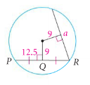

QC 2: What is the value of x in the circle below?
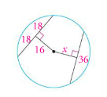

C) Find AB in the circle below.

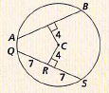

Objective 2: I can recognize properties of lines through the center of a circle.

Below are some more theorems about lines through circles.
Theorem 12-6:
In a circle, a ______________ that is _________________ to a ____________ bisects the chord and its arcs.

Theorem 12-7:
In a circle, a ___________ that bisects a ________ (that is not a diameter) is ________________
to the chord.

Theorem 12-8:
In a circle, the ________________________ of a _________ contains the center of the circle.

Example 3: Find each missing length in the circles below.
A)
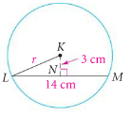

B)
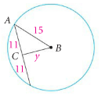

C)
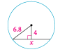

Practice Problems: Find the value of each variable.
1. 2.
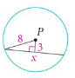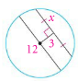

3. 4.
