Geometry 12-1: Tangent Lines

Objective 1: I can use the relationship between a radius of a circle and a tangent line.
In chapter 8, you studied the tangent ratio in right triangles:. The tangents you will student in chapter 12 will relate to ______________, not triangles.

A ______________ to a circle is a line that intersects the circle in exactly ______ point.
Draw a tangent line to the circle below. Label the circle as circle C.

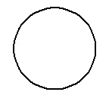

The point where a circle and a tangent line intersect is called the _________________________. Label it point B above.
Draw above. _________ is a tangent ray and _______ is a tangent segment to your circle.

The theorem below shows the relationship between a tangent line and the radius of a circle.

Theorem 12-1:
If a line is tangent to a circle, then
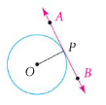

Example 1: A) and are tangent to . Find the value of x below.
Solution: Recall that the angles of any quadrilateral add to ______. Using theorem 12-1, we know that the and .
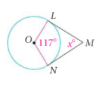
B)
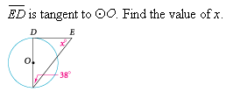

C)
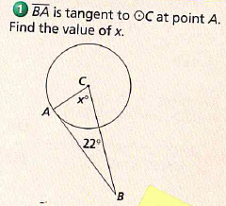

Theorem 12-2 is the converse of Theorem 12-1. You can use it to prove that a line or segment is _____________ to a circle.

Theorem 12-2:
If a line is perpendicular to the radius at its endpoint on the circle,
then
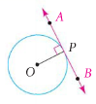

Example 2: Use the information to verify that a given segment is a tangent line to a circle.
A) Is tangent to at L? Explain.

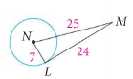

B) Using the figure above, if NL = 4, LM = 7, and NM = 8, is tangent to at L? Explain.
C) has radius 5. Point P is outside of such that PO = 12. Point A is on such that PA = 13. Is tangent to at A? Explain.

Objective 2: I can use multiple tangents of a circle to find missing information.
Sometimes we can draw shapes inside each other. For example, we can draw a circle inside a triangle, or draw a triangle inside a circle. These drawings have special names.

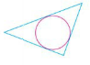

In the figure above, the circle is ______________ in the triangle. We could also say that the triangle is ______________________ about the circle. Notice that each side of the triangle touches the circle in exactly one point, so each side of the triangle is ______________ to the circle. When a circle is _____________ inside of a polygon, the tangent segments from each vertex are __________. Let’s label the segments in the circle above.

Theorem 12-3:
The two segments tangent to a circle from a point
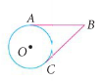

Example 1: is inscribed in Find the perimeter of

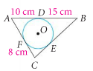

Example 2: is inscribed in The perimeter of is 88cm. Find QY.

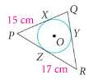

Example 3: is inscribed in quadrilateral WXYZ. Find the perimeter of WXYZ.

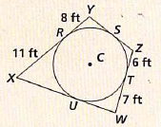

Additional Homework Problems
