Geometry 10.7: Areas of Circles and Sectors

Objective: Finding areas of parts of circles
Just like the length of an arc is part of the circumference of a circle, the area of a _____________
is part of the area of the entire circle. Recall that the area of a circle is A = ______________. A
_________________________ is the region bounded by an ____of the circle and two ________ of the circle. You name a sector using ______________________________________________
___________________. The slice of pizza below is a part of the entire pizza, so it is a sector. Name the sector shown in the slice of pizza below.

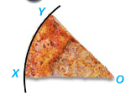

We can find the area of a sector using a proportion as we found arc length in the previous section. The area of a sector is a fractional part of the area of a circle.

Theorem 10-12: Area of a Sector of a Circle

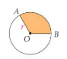

Example 1: Find the area of sector ZOM. Leave your answer in terms of $π$ and to the nearest tenth.

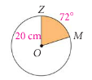

Example 2: Find the area of sector BCA. Leave your answer in terms of $π$ and to the nearest tenth.

