**H. Geometry - Bellwork #43 Thursday, April 25th, 2019**

Find the area of each regular polygon. Round to the nearest hundredth.

1. Pentagon with radius 12 cm. 2. Nonagon with apothem 7.5 in.

3. Equilateral triangle with side length 16 mm. 4. Decagon with radius 11.5 in.

Find the area of each trapezoid/rhombus. Round to the nearest hundredth, if necessary. $A=\frac{1}{2}\left(b1+b2\right)h A=\frac{1}{2}d1d2$

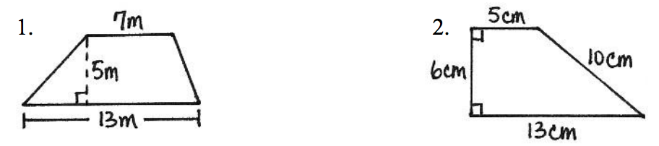

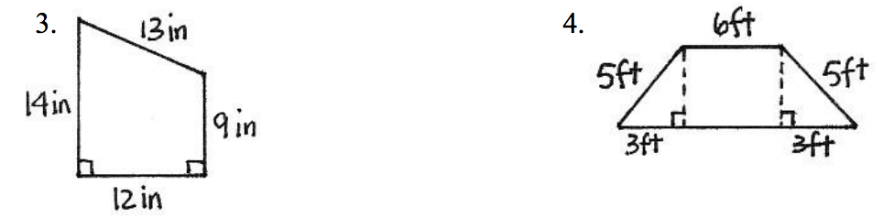

15 ft

11 ft

5. 6.

50 in.

40 in