Geometry Introduction to Chapter 12 Vocabulary (10.6)

Objective 1: I can identify parts of a circle.

In a plane, a circle is the set of all points ___________________ from a given point, called the _____________. You name a circle by its _____________. Name the circle below.
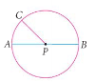

A __________ of a circle is a segment that has one endpoint at the __________ of the circle and the other endpoint _____________________.

A ___________ of a circle is a segment that contains the __________ of a circle and has both _____________ on the circle.

A _____________________ is an angle whose ___________ is the ___________ of the circle.

Example 1: Use the circle above to name each:

A radius: A diameter: A central angle:

QC 1: Use the circle below to name each. There may be more than one answer.

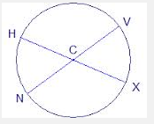

A radius A diameter A central angle

Besides radius and diameter, there are other important parts of a circle that we should know.

An _______ is a part of a circle.
A semicircle is ______________________________.
A minor arc is _______________________________.
A ____________________ is greater than a semicircle.
We write the symbol ______ above the letters of an arc to show it is an arc.

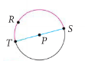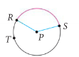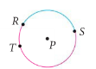

Example 2: Identify the following parts of circle O.
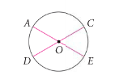

a) the minor arcs b) the semicircles c) the major arcs that contain point A

Classwork: Use the circles to find each part.
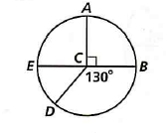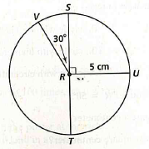

A) a radius A) a radius
B) a diameter B) a diameter
C) a minor arc C) a minor arc
D) a major arc D) a major arc
E) a semicircle E) a semicircle
F) a major arc containing point D F) a minor arc containing point S

